**\*\*\*\*ANTI SLEEP DEVICE\*\*\*\***

INTRODUCTION :

Owing to today’s fast paced world, the stress load has increased and has made it difficult for us to focus on one task. We, are constantly busy and always tired. Living in such a state of perpetual tiredness is dangerous not only for ourselves but for our surroundings too. A person driving home for a long day’s work may get drowsy in front of the wheel. His hands are on the steering wheel and his feet on the pedal but he is succumbing to his sleepiness. This is a dangerous situation that can lead to fatalities. Accidents due to drivers falling asleep while driving are common and it is imperative that we counter this problem. So, to address this issue, we have come up with a Driver Anti-sleep Device. This system alerts the user if he/she falls asleep at the wheel thereby, avoiding accidents and saving lives. This is very useful for people who frequently travel long distances by car and late night journeys. Mostly needed by drivers such as truck drivers as they travel a long duration of time and can sleep due to tiredness. Office hour people after working for long hours like IT people who generally work late at night. Long distance driving and in that if someone is sleeping beside the driver it can cause distraction. Driver sleepiness and falling asleep at the wheel are considered to cause a significant proportion of road traffic accidents, particularly during night driving. The purpose of a sleepiness detection device is to warn of unexpected sleepiness, and is in no way intended to keep the driver awake. The alarm continues for a minimum of 10 seconds so that the driver wakes and get ready to steady the vehicle he drives. Thus, we can control the major accidents.

OBJECTIVE:

In this project, we aim to create a driver anti sleep device detector, using buzzer which helps to wake up the driver.

We aim to design the circuit for this project using hardware components as well

COMPONENTS REQUIRED:

* 555 Timer IC
* Buzzer
* Resistors
* Capacitors
* Transistors
* Cables and Connectors
* Diodes
* PCB and Breadboards
* LED
* Transformer/Adapter
* Push Buttons
* Switch
* IC Sockets Relay

BLOCK DIAGRAM: 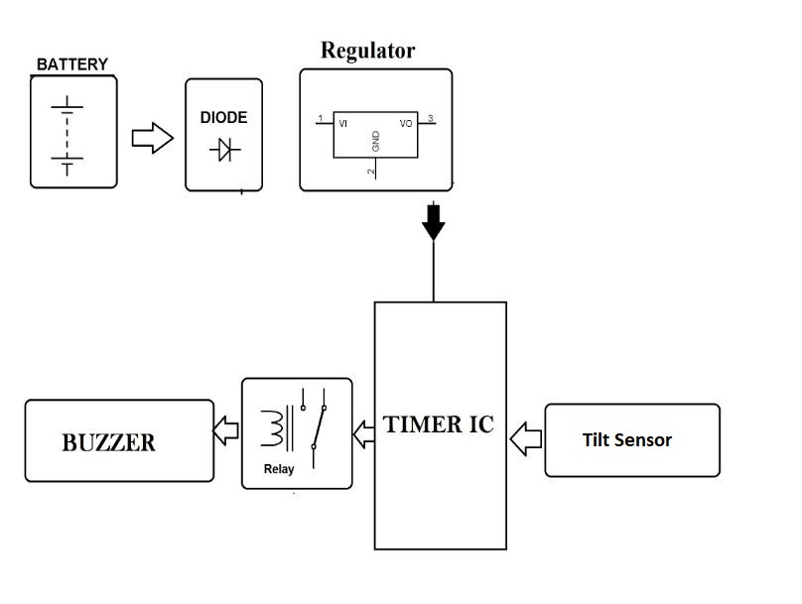

PROPOSED METHODOLOGY

The circuit is built using 555 timer IC as a switch, transistor, relay and a tilt sensor. The circuit is built around Schmitt trigger, timer IC, transistor, a relay and a logic gate. Around half an hour after the reset of timer IC, transistors rive the buzzer to sound an intermediate beep. If timer IC is not reset at that time, around one minute later the output of gate conducts. Due to this the clock stops counting further and relay energizes to deactivate the load. This state changes only reset switch is pressed. As a result of pressing the reset switch a next timer is set which will trigger the same events after half an hour.

CIRCUIT DIAGRAM:

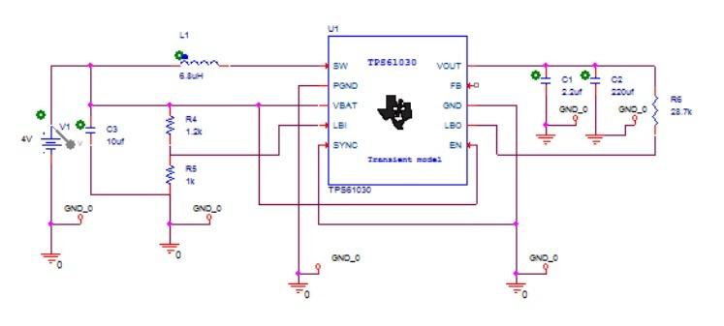

EXPECTED RESULTS:

Whenever the driver feels sleepy and puts his head down, the tilt sensor detects and transistor drives the buzzer to sound an intermediate beep and LED’s start glowing. When the driver comes back to his normal position tilt sensor senses that and the buzzer and LED switches off.



REFERENCES:

* [www.engineersgarage.com](http://www.engineersgarage.com/)
* [www.nevonproject.com](http://www.nevonproject.com)
* [www.jetir.org](http://www.jetir.org/)
* [www.electronicsforu.com](http://www.electronicsforu.com)